**Assignment 1: Installing and Building Gem5**

**Introduction**

There are several simulators have been proposed and invented based on the architecture of a computer system. Gem5 is one of them which is known as an open-source community-supported full-system computer architecture simulation tool. This tool is a merger version of M5 (Binkert, 2006) and GEMS (Martin, 2005). Thus, this simulator allows us to make configurations for simulation, alongside multiple ISAs, diverse CPU models, multiple cache coherence protocols and interconnect models. This tool is used by various academic researchers and several market-leading organisations like ARM Research, AMD Research, Google, Micron, HP, and Samsung. This tool can be used in multiple system architectures like x86, Arm®, and RISC-V (Binkert, 2011).

Environment Setup

The software required for building gem5 are python, scons, gcc, zlib, m4, git etc. Apart from that, for certain builds, libprotobuf-dev and protobuf-compiler required.

Once the prerequisites are setup, the cloning of the gem5 repository will be cloned.

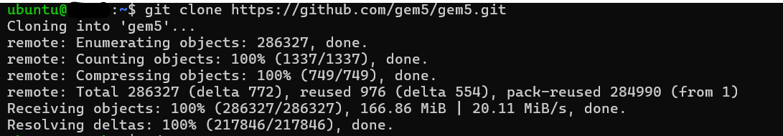

Then the directory was set and started building gem5.



Once the building has been completed the outcome is like the following.

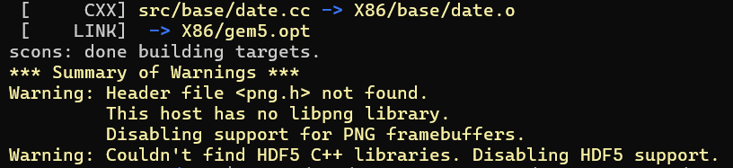

**Troubleshooting**

The dependencies are missing in the very first phase. Then observing the errors, the missing dependencies are installed to make the build successful.

**References**

Binkert, N. L., Dreslinski, R. G., Hsu, L. R., Lim, K. T., Saidi, A. G., & Reinhardt, S. K. (2006). The M5 simulator: Modeling networked systems. *Ieee micro*, *26*(4), 52-60.

Binkert, N., Beckmann, B., Black, G., Reinhardt, S. K., Saidi, A., Basu, A., ... & Wood, D. A. (2011). The gem5 simulator. *ACM SIGARCH computer architecture news*, *39*(2), 1-7.

Martin, M. M., Sorin, D. J., Beckmann, B. M., Marty, M. R., Xu, M., Alameldeen, A. R., ... & Wood, D. A. (2005). Multifacet's general execution-driven multiprocessor simulator (GEMS) toolset. *ACM SIGARCH Computer Architecture News*, *33*(4), 92-99.